Data extraction instructions
Air waybill
The data required to extract from these documents is:
- Document number
- Date (latest date on document if a range of dates is given)
- Total Amount & Currency (if three decimal places this will be Dinars)
- Piece Number (if indicated)
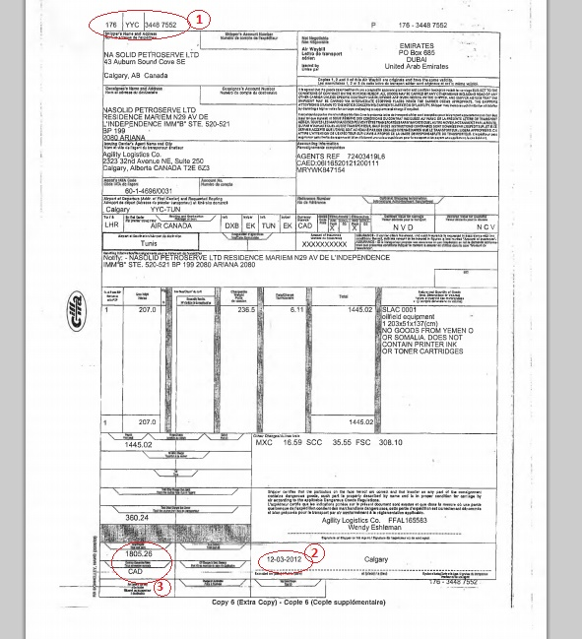
In this example, the information to extract would include:
- Document number: 176YYC34487552
- Date: 12.03.12
- Amount: 1805.26 CAD
Here is another example
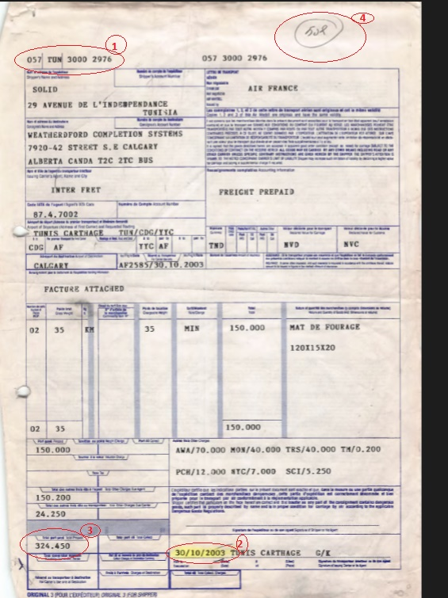
- Piece Number: 508
Bank Statements (Releve de Comptes)
The data required to extract from these documents is:
- Account number
- Date (latest date on document if a range of dates is given)
- Piece Number (if indicated)
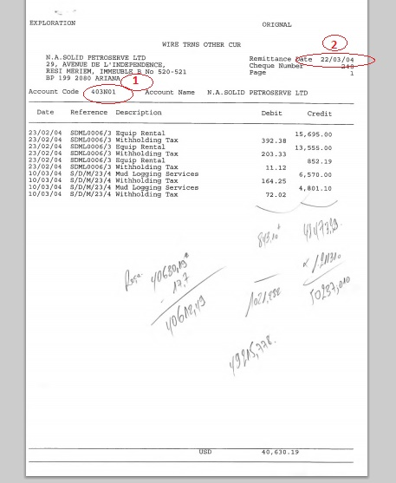
In this example, the information to extract would include:
- Account number: 403N01
- Date: 22.03.2004
Here is another example:
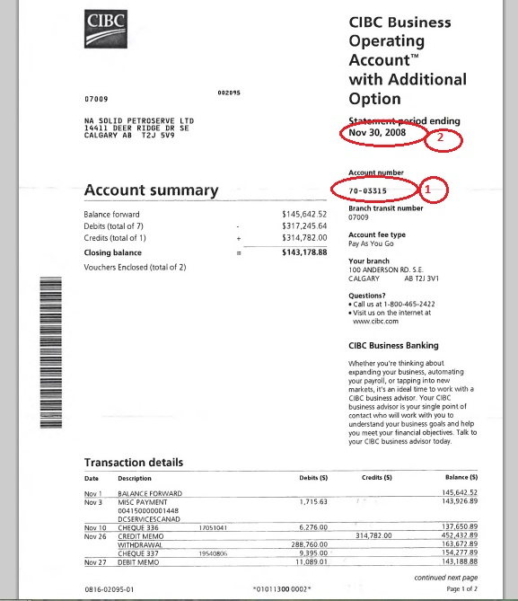
In this example, the information to extract would include:
- Account number: 70-03315
- Date: 30.11.2008
Bon de Livraison
The data required to extract from these documents is:
- Date (latest date on document if a range of dates is given)
- Fracture Number
- Company name
- Total Amount & Currency (if three decimal places this will be Dinars)
- Piece Number (if indicated)

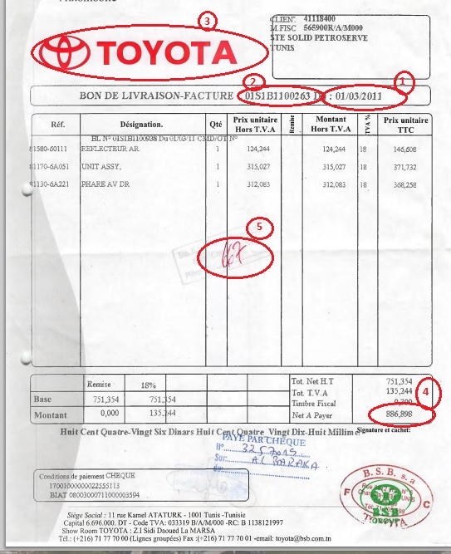
In the above example, the information to extract would be:
- Date: 01.03.2011
- Fracture Number: 01S1B1100263
- Company name: Toyota
- Total Amount & Currency: 886.898 TD
- Piece Number: 667
Here is another example:
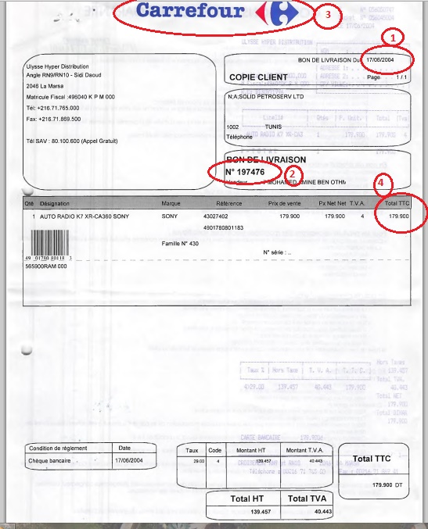
In the above example, the information to extract would be:
- Date: 17.06.2004
- Fracture Number: 197476
- Company name: Carrefour
- Total Amount & Currency: 179.900 TD
Catering
The data required to extract from these documents is:
- Date (latest date on document if a range of dates is given)
- Company name
- Total Amount & Currency (if three decimal places this will be Dinars)
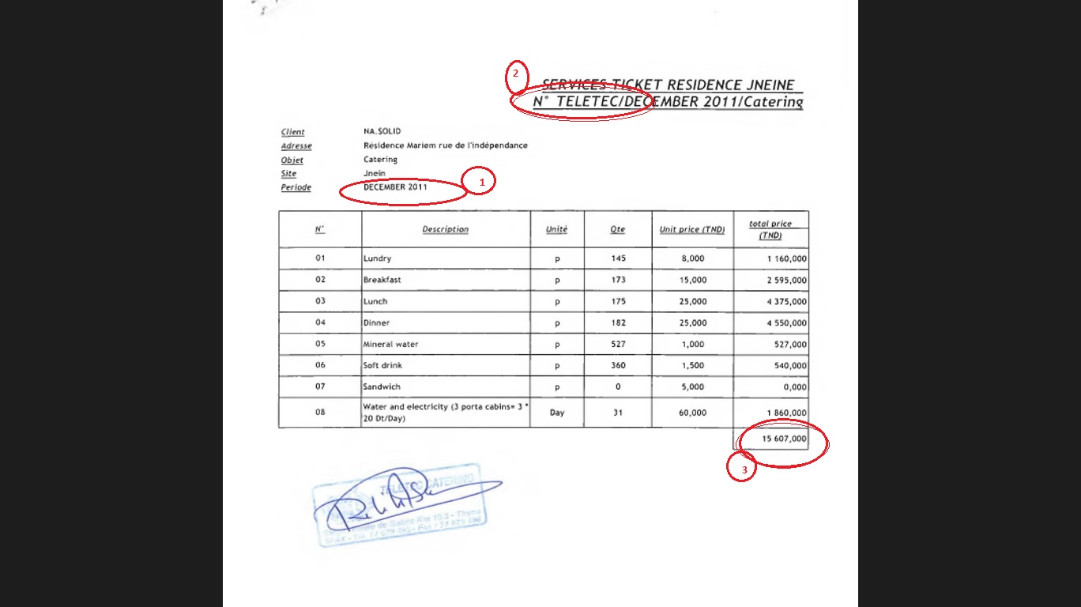
In the above example, the information to extract would be:
- Date: 00.12.2011
- Company name: Teletec
- Total Amount & Currency: 15607,000 TD
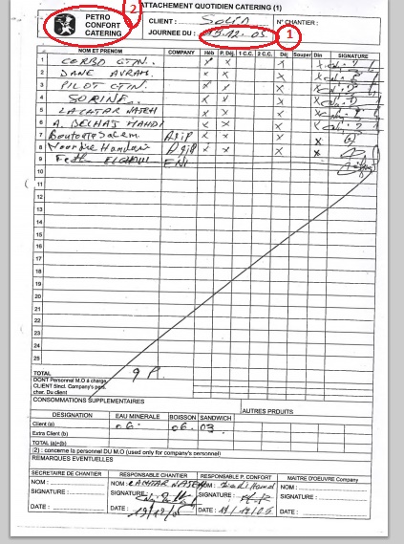
In the above example, the information to extract would be:
- Date: 13.12.05
- Company name: Petro Confort Catering
- Total Amount & Currency: missing
Email
The data required to extract from these documents is:
- Sender/From/De (enter all data in the line)
- Recipient/To/A (enter all data in the line)
- Date
The month may be listed in French, the English translations are below.
January | janvier
February | février
March | mars
April | avril
May | mai
June | juin
July | Juillet
August | août
September | septembre
October | octobre
November | Novembre
December | Décembre
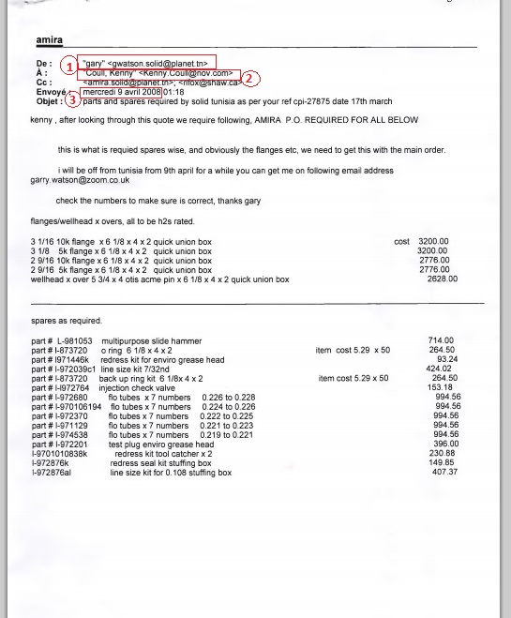
In the above example, the information to extract would be:
- Sender/From/De: “gary” ˂gwatson.solid@planet.tn˃
- Recipient/To/A: ‘’Coull, Kenny’’ ˂Kenny.Coull@nov.com˃
- Date: 09.04.2008
Eni Tunisia
The data required to extract from these documents is:
- Date (latest date on document if a range of dates is given)
- Document Number / Facture Number (Numero de call off)
- Purchase Order Number: (Please, write in the Purchase Order Number field)
- Total Amount & Currency (if three decimal places this will be Dinars)
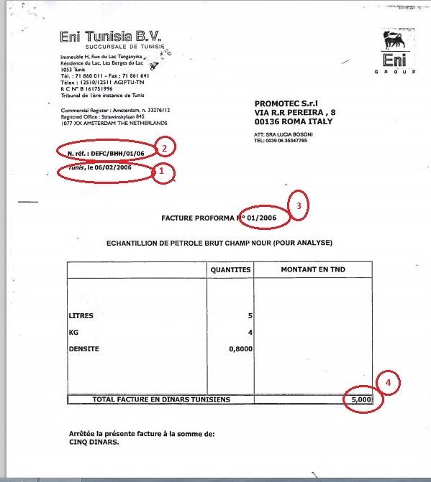
In the above example, the information to extract would be:
- Date: 06.02.2006
- Document Number / Facture number (Numero de call off): DEFC/BHH/01/06
- Purchase Order Number: (Please, write in the Purchase Order Number field)
- Total Amount & Currency: 5,000 TD
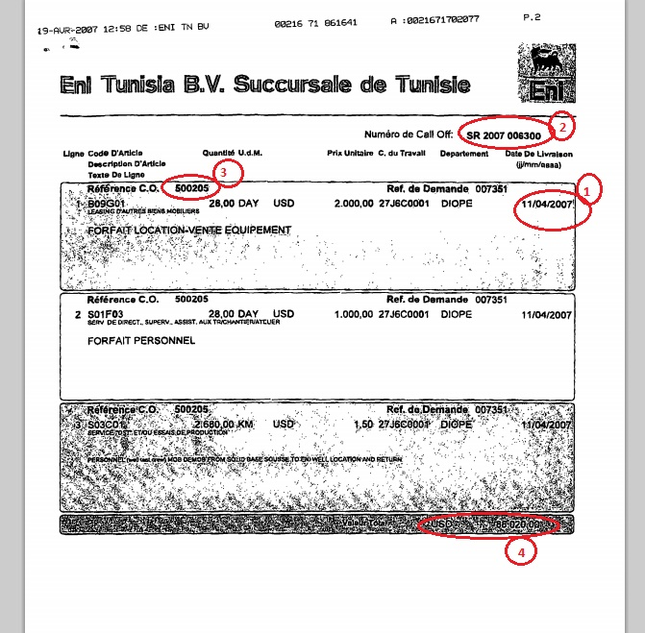
In the above example, the information to extract would be:
- Date: 11.04.2007
- Document Number (Numero de call off): SR 2007 006200
- Purchase Order Number :500205
- Total Amount & Currency: 88020,00 USD

